Simulation # 8

**Digital Logical Gates in Multisim**



**Electrical Network Simulation Laboratory (EE2701)**

*Department of Electrical Engineering,*

*NIT Rourkela*

**Aim**: **Simulate and verify the outputs of various logical gates**

**Theory:** Digital systems are said to be constructed by using logic gates. These gates are the AND, OR, NOT, NAND, NOR, EXOR and EXNOR gates. The basic operations are described below with the aid of truth tables.

**2-input AND Gate:**

For a 2-input AND gate, the output Q is true if BOTH input A “AND” input B are both true, giving the Boolean Expression of: (Q = A and B).

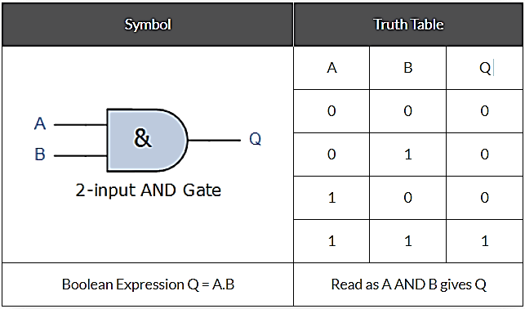

**2-input OR (Inclusive OR) Gate:**

For a 2-input OR gate, the output Q is true if EITHER input A “OR” input B is true, giving the Boolean Expression of: (Q = A or B).

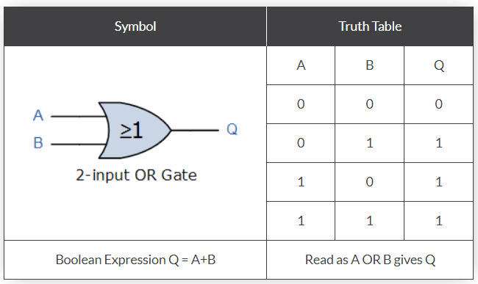

**NOT Gate:** For a single input NOT gate, the output Q is ONLY true when the input is “NOT” true, the output is the inverse or complement of the input giving the Boolean Expression of: ( Q = NOT A ).

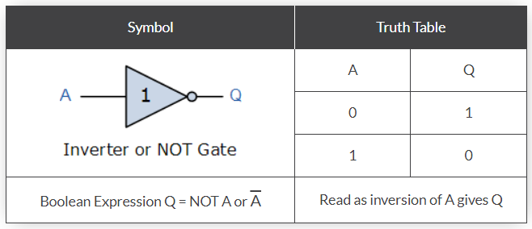

The NAND and the NOR Gates are a combination of the AND and OR Gates with that of a NOT Gate or inverter.

**2-input NAND (Not AND) Gate:**

For a 2-input NAND gate, the output Q is true if BOTH input A and input B are NOT true, giving the Boolean Expression of: (Q = not (A and B)).

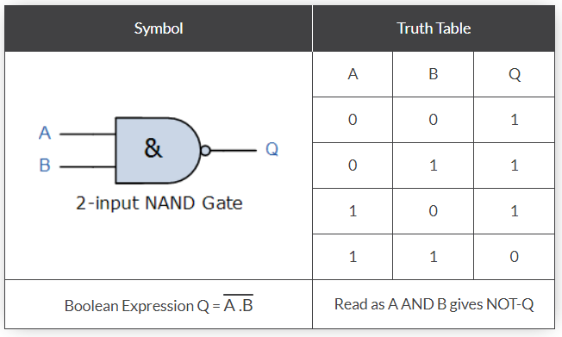

**2-input NOR (Not OR) Gate:**

For a 2-input NOR gate, the output Q is true if BOTH input A and input B are NOT true, giving the Boolean Expression of: (Q = not(A or B) ).

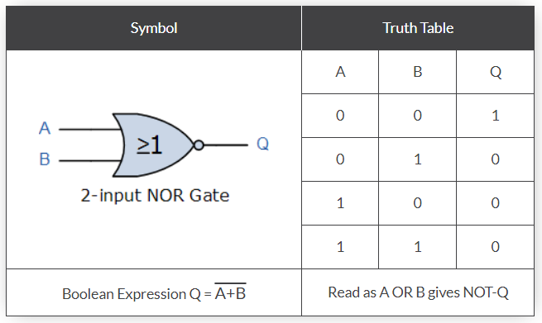

There are two special types of logic gate function called an Exclusive-OR Gate and an Exclusive-NOR Gate. The actions of both of these types of gates can be simulated using the above standard gates. However, as they are widely used functions, they are now available in standard IC form and have been included here as reference.

**2-input EX-OR (Exclusive OR) Gate:**

For a 2-input Ex-OR gate, the output Q is true if EITHER input A or if input B is true, but NOT both giving the Boolean Expression of: ( Q = (A and NOT B) or (NOT A and B) ).

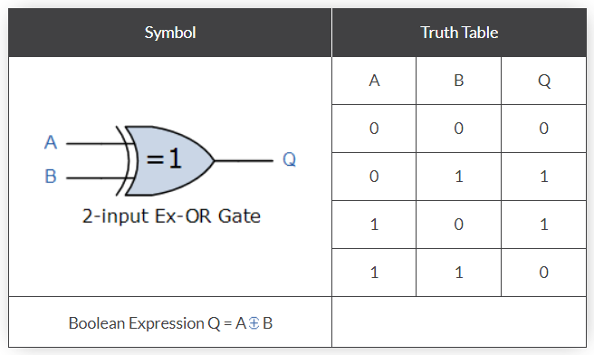

**2-input EX-NOR (Exclusive NOR) Gate:**

For a 2-input Ex-NOR gate, the output Q is true if BOTH input A and input B are the same, either true or false, giving the Boolean Expression of: ( Q = (A and B) or (NOT A and NOT B) ).

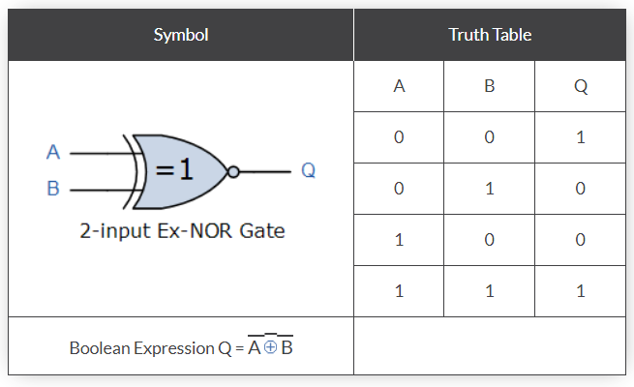

The following table lists of the common logic functions and their equivalent Boolean notation.

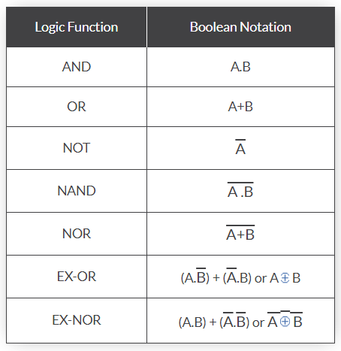

2-input logic gate truth tables are given here as examples of the operation of each logic function, but there are many more logic gates with 3, 4 even 8 individual inputs. The multiple input gates are no different to the simple 2-input gates above, So a 4-input AND gate would still require ALL 4-inputs to be present to produce the required output at Q and its larger truth table would reflect that.

**Procedure:**

**Section-I**

1. **Simulation of 2-input AND Gate in Multisim:**

From Interactive digital constant library two digital signal switches are connected to the two the input ends of AND gate. The output pin is connected with a probe. The circuit simulations are done as shown in fig.

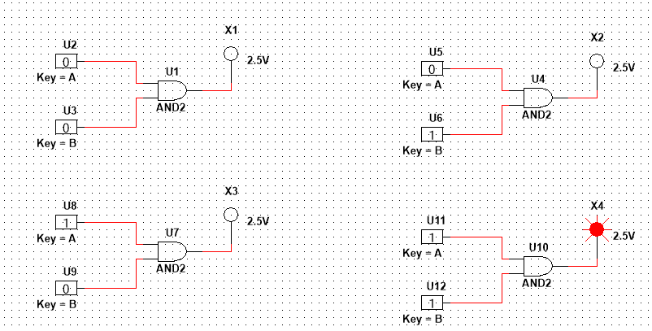

Circuit simulation of 2-input AND Gate with all logical cases

1. **Verification of the truth table using logic converter:**

The Logic convertor can be obtained from **Simulate** → **Instrument** library**.**

The Logic convertor contains 8 channels, before simulation the channels connected to the signal sources must be defined as shown in fig.

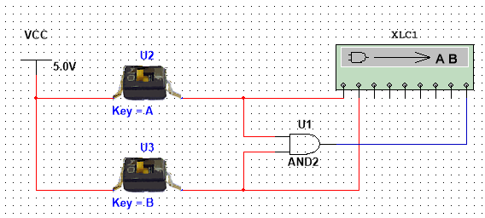

Logic converter connection

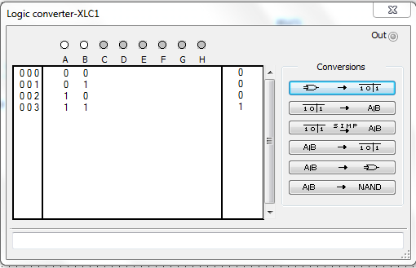

Logic converter truth table

1. **Verification of Output wave forms of 2-input AND Gate** **using piecewise linear voltage signal source:**

The Piecewise linear voltage signal source is selected from “Place Source → Signal voltage source”. The 2-input AND Gate is connected with the separate voltage signal sources and Output is connected with a lamp with respect to ground. If a voltmeter is connected across the lamp, it indicates the output signals of the AND gate.

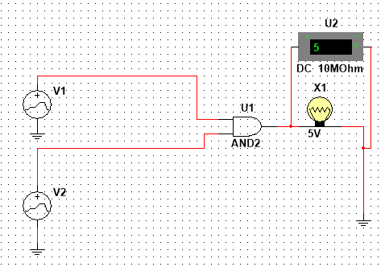

2-input AND Gate connection with voltage signal source

1. **Simulation:**

The Output wave forms of 2-input AND Gate can be obtained by the steps given:

“ Simulate → Analysis → Transient analysis → Analysis parameters →(The parameters values are given in fig).

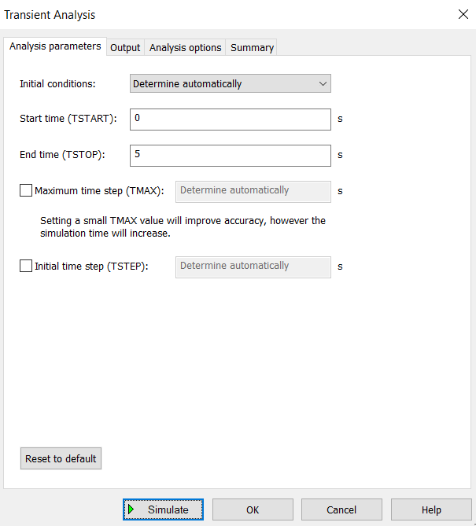 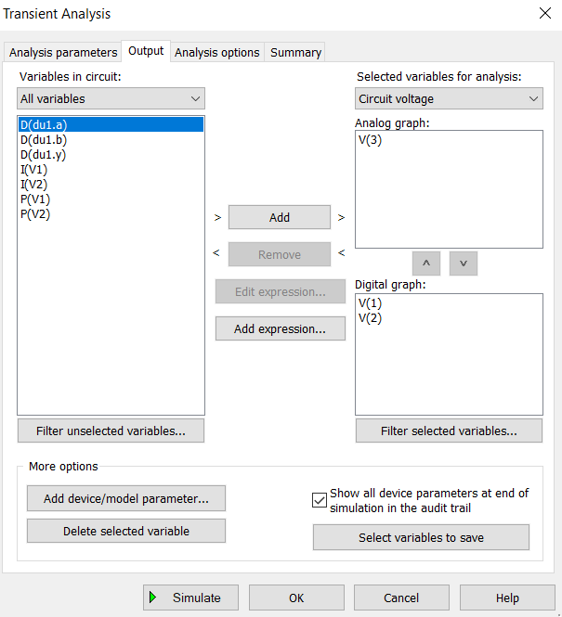

Digital graph Output setting

1. **Output wave forms:**

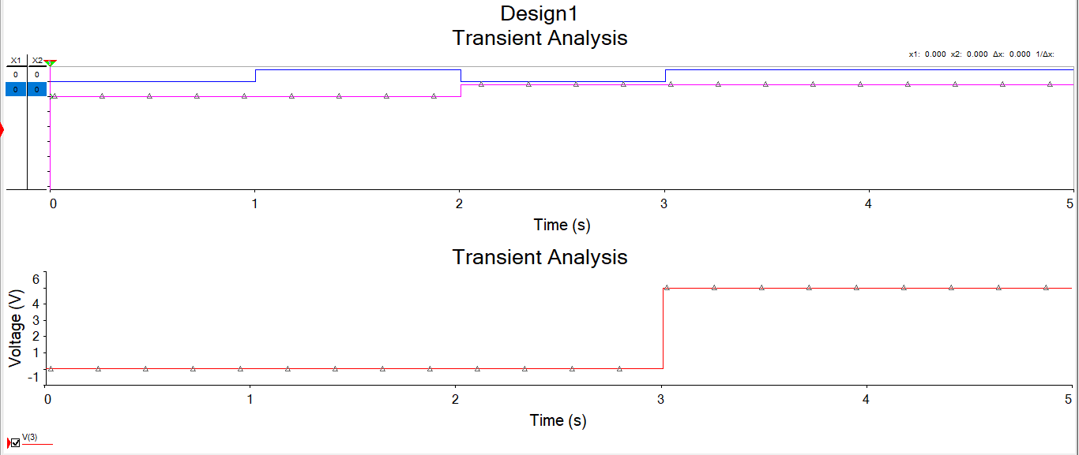

Output wave forms of 2-input AND Gate

**Section-II**

1. **Simulation of 3-input NAND Gate using TTL interface (74S10N):**

**Procedure:** Follow similar procedure as given in section I.

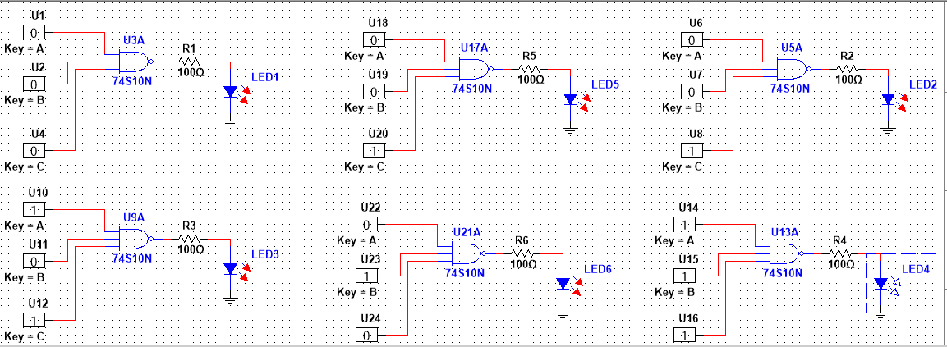

Circuit simulation of 3-input NAND Gate with logical cases

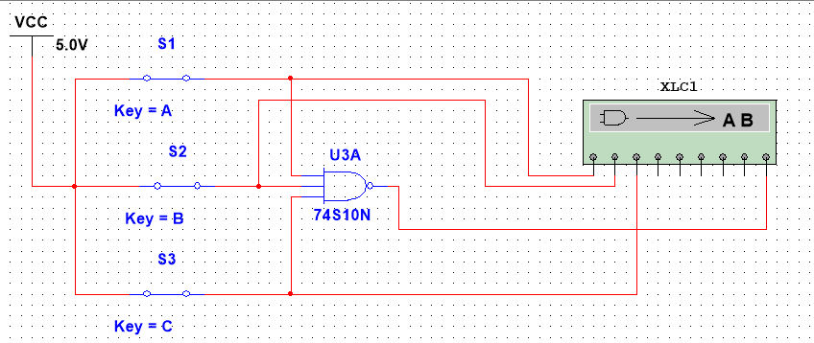

Logic converter connection

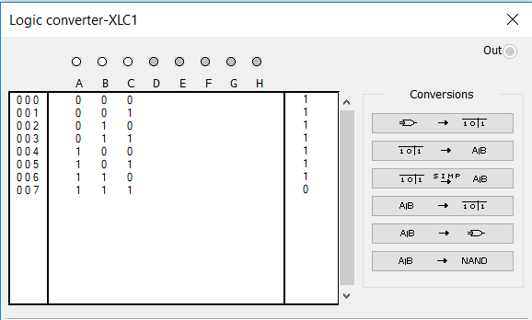

Logic converter Truth table

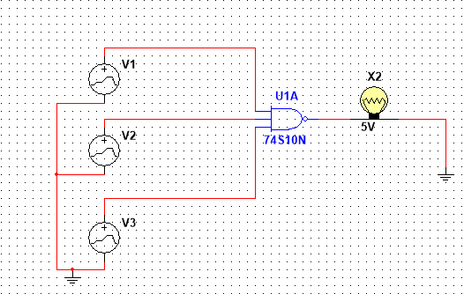

circuit diagram of 3-input NAND Gate, IC 74S10N

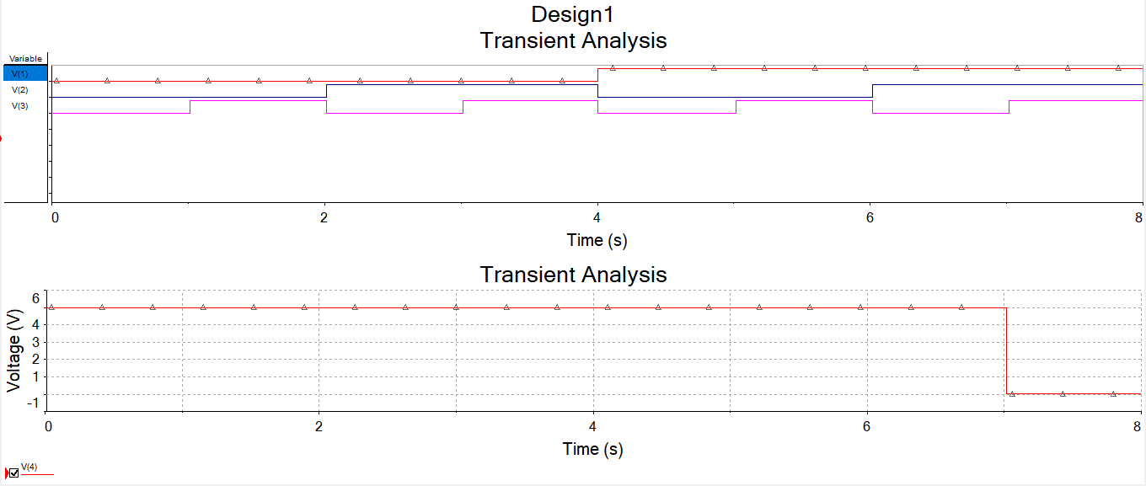

Output wave forms of 3-input NAND Gate

**Questions:**

1. Simulate 3-input NOR Gate & AND Gate using TTL interface (IC- 7427N, 74LS15N)
2. Why NAND & NOR gates are called universal gates? Elaborate with a simulated example.
3. Realize the EXOR gate using minimum number of NAND gates.
4. What are the logic low and High levels of TTL IC’s and CMOS IC’s.
5. Compare TTL logic family with CMOS family.